Weekly Report

📆 **Week:** 2025/02/25 - 2025/02/27  
👤 **Internship Position:** Equity Research Intern  
🏢 **Company:** Asian Technology Advisor  
👨‍💼 **Supervisor:** Cecilia, Andy

1. **Tasks Completed**

[✔] Continue ***Statistical Analysis on Beat/Miss*** and refining analysis framework

[✔] Visualization and analysis of ***stock price retrace pattern/distribution*** after beat up/beat down

[✔] Make a strategy and redefine Best/Miss (4 situations -> **5 situations**, add “***fluctuate***”)

[✔] Visualization and analysis Alpha when beat/miss (not primary goal, low priority)

[✔] Analysis on the relationship between Alpha and beat/miss size

1. **Key Achievements**

***Background***:

The focus of this week remained on analyzing indicators/changes/trend of stock price after beat/miss. In order to give suggestions on when to add/reduce a position, I suppose it’s important to analysis the trend of a certain indicator then then strategies could be given. I spent sometimes on alpha but there’s no significant findings. After alignment with Cecilia and discussion with Andi, I switched to ***stock price change*** and got some preliminary insights. The definition of the four situations are not well made and I set up new definitions, adding “***fluctuate***” as the 5th situation. The analysis on stock price change uses my new definition. I also analyzed the alpha and beat size’s relationship and found that there’s no significant relationship.

***Phase Outcomes:***

1. ***New Definition of the 5 situations:***

In order to analyze the stock price change and calculate the retrace, we need ***further and strict definitions*** of the 5 situations. For example, Our ***previous definition*** for beat up is “***stock return > 0 on the 1st trading day after earnings***”

***[The Reason for Redefinition]*** Figure 1 describes NVDA stock price changes for multiple beat-ups in the last 5 years. Here, the stock price is actually the ***stock return R = (Pt - P0 ) / P0.*** For the red line (2020-11-18), it has a very small positive return on day 1 (0.01%), and then the price continues to decline. It should be classified as a “beat down” here when we make position adjustment strategy because it’s return remained to below zero for a long time considering its trend. According to my observation, many beat up/ beat down are wrongly categorized.

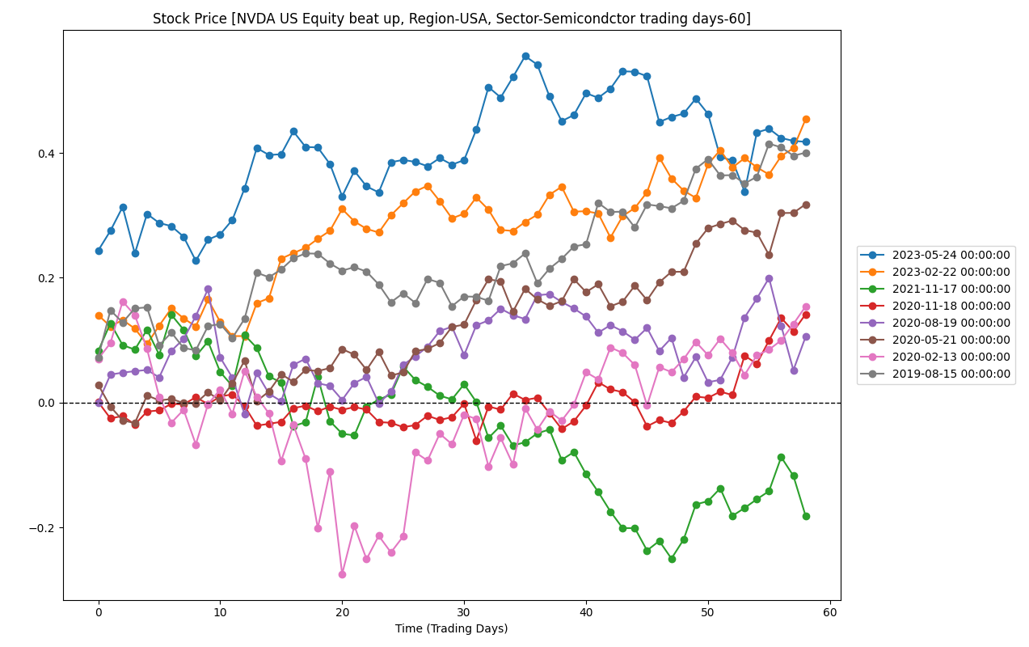

Figure 1

***[Previous definition VS Current definition]***

Current definition takes trend into consideration.

Beat/Miss is decided if the surprise is positive or negative.

***Previous***:

Up/down: 1st day return above zero (up), 1st day return below zero (down).

***Current:***

***Up:*** ① average of the first four trading days ***above*** zero

② In the first four trading days, three of them have a return ***greater*** than zero

③ The 3rd, 4th return must greater than zero

***Down:*** ① average of the first four trading days ***below*** zero

② In the first four trading days, three of them have a return ***lower*** than zero

③ The 3rd, 4th return must ***lower*** than zero

The rest is categorized as “Fluctuate” (the 5th situation)

Figure 2 is the Beat up of NVDA under new definition.

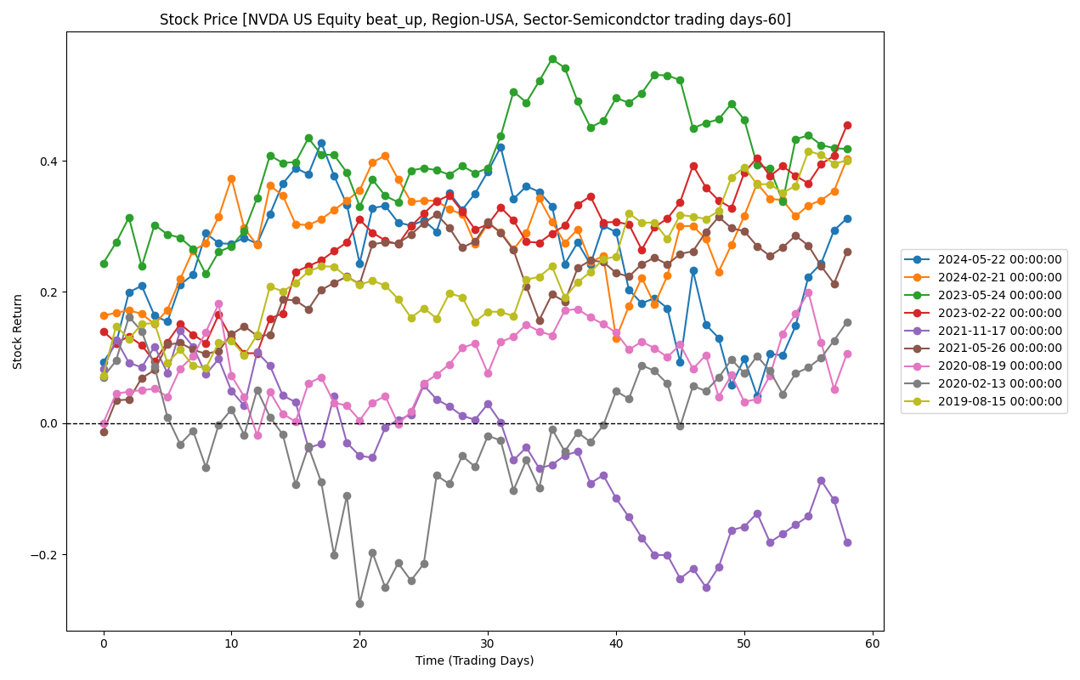

Figure 2

1. ***Analysis of Retrace in Stock Price***

The Retrace here is defined as : For a “up” situation, a retrace is the time when the return goes below zero. For a “down” situation, a retrace is the time when the goes above zero.

I only analyzed beat up and beat down because 95% of the time it beats and the sample of miss is too small in semiconductor. I will include more data to analysis miss next week.

For “up” situation, the return could 1. continue to be above zero 2.retrace to below zero. This is the same with “down” situation.

Conclusion 1: “down” situation is more likely to retrace than “up”, but it varies across different company

As shown in the figure below, 60% percent of the equities in semi-conductor sector, U.S. retrace after a beat up, while 70% percent retrace. However, when comparing Figure 2 with Figure 3,we 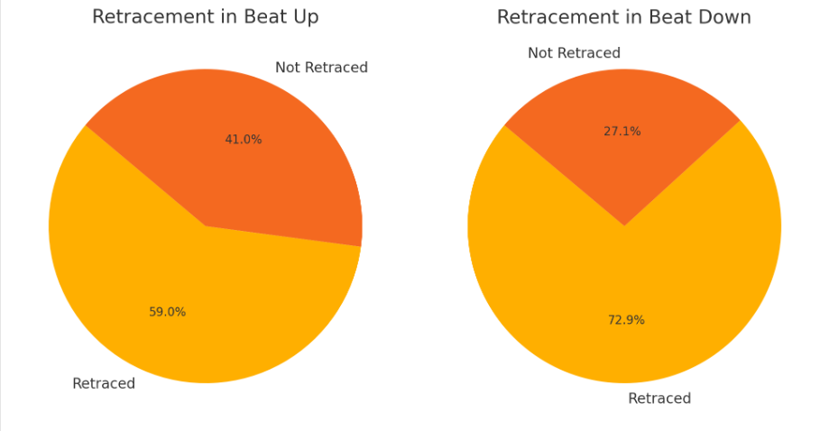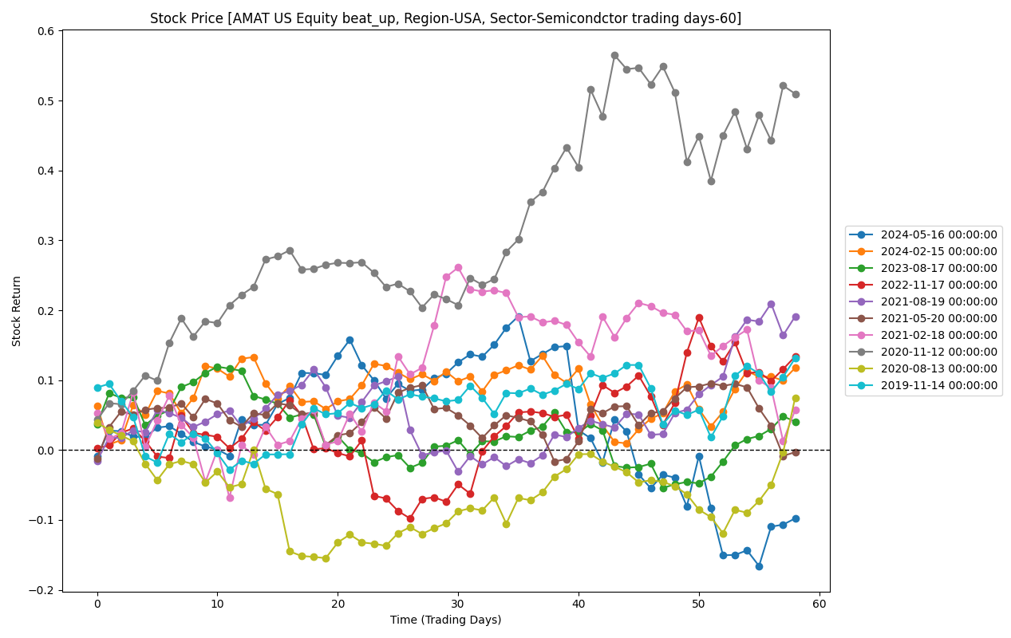

Figure 3. AMAT, Beat Up

can observe that the beat up of AMAT is more likely to retrace than NVDA.

Conclusion2: 5 day is the most common retrace for both beat up and beat down

The distribution of Retrace of beat up/down is as shown in Figure 4 and 5. It can be observed that for both beat up and beat down, the most common retrace day would be the 5th trading day.

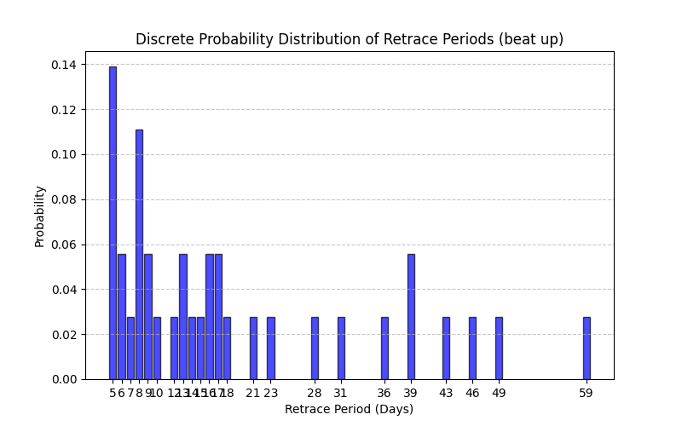

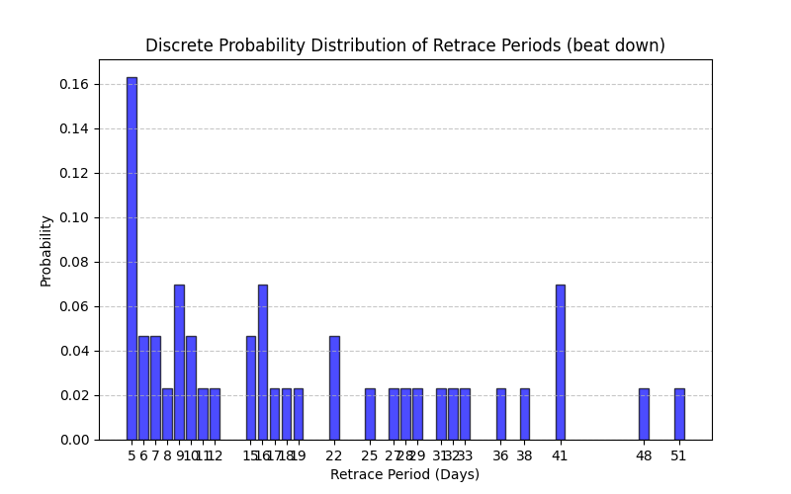

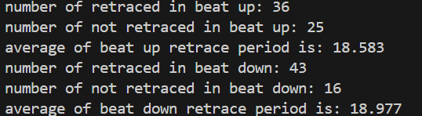

1. ***Alpha analysis / Relation between Alpha and beat size***

With the implement of new definitions of “up” and “down”, the avg alpha looks better. For the beat up,most of the alpha is above zero in the past 5 years.

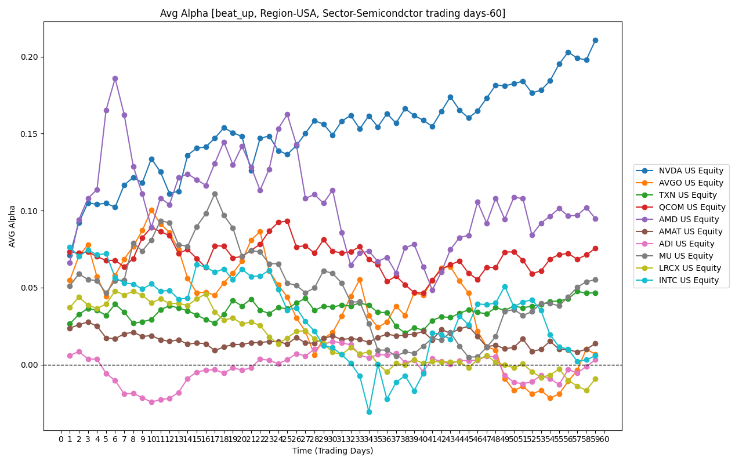

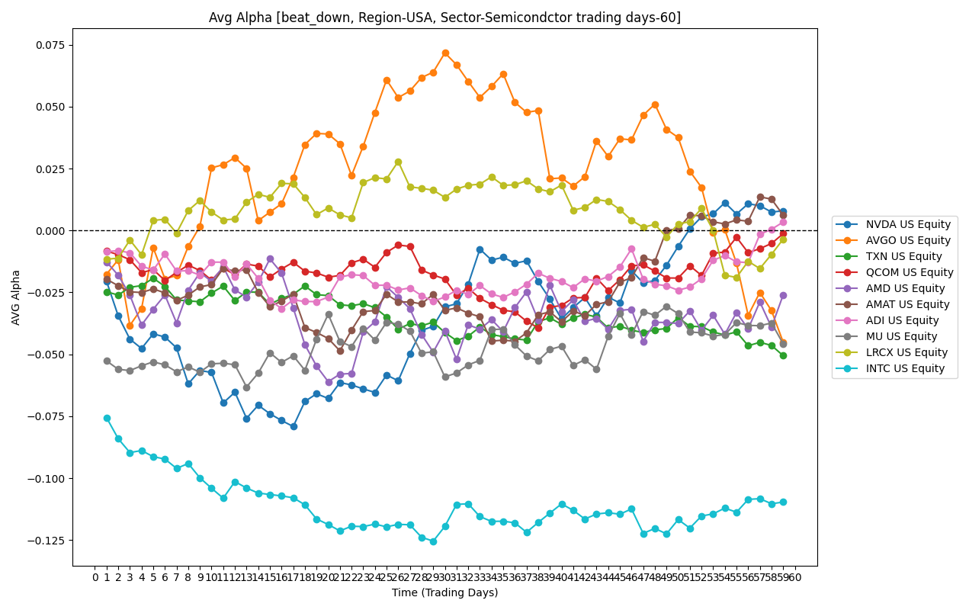

According to the figures below, there is no significant relationship between beat size and alpha. An OLS test proved this conclusion.

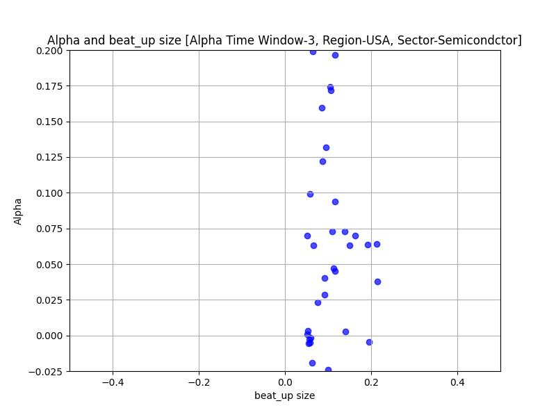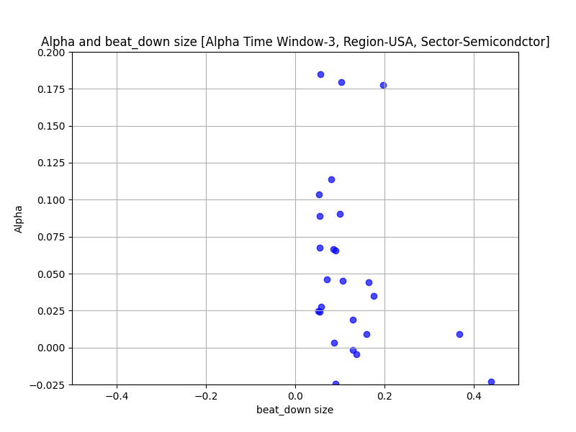

1. Challenges

Challenge 1: How we define the “up/down” situation is still a tricky problem. It influences significantly on the retrace period and position strategy.

Solution: More discussion and alignment. Besides, when the goal is different, the definition would be different.

Challenge 2: The sample size is small, especially for miss.

Solution: Include more equities, adjusting miss thresholds.

Challenge 3: Take beat up as an example, it could retrace and it may not retrace

Solution: Machine learning method could be a tool for decision making on whether a beat up will retrace or not retrace

Challenge 4: The retrace pattern various across different companies

Solution: Using data from different companies and sectors/ regions to find patterns

1. Next Week’s Plan

* Thinking about a good definition of the situations.(Currently the definition for “fluctuate” is not good)
* Run more results on different companies, different sectors and regions
* Try other analysis methods to find a suitable retrace for different situation
* Support other Analysts (Gaming device data summarization to support Sen)